

ELECTRICITY PRICES PREDICTION

(GROUP 2-PHASE 3)

DEVELOPMENT PART

SUBMITTED BY-

J.NISHA

Download the Dataset:

Go to the Kaggle dataset link you provided and download the dataset in a format such as CSV.

Install Required Libraries:

Ensure that you have the necessary libraries installed, such as Pandas, NumPy, and scikit-learn. You can install them using pip:

pip install pandas numpyscikit-learn

Load the Dataset:

Use Pandas to load the dataset into a DataFrame:

import pandas as pd

# Replace 'your_dataset.csv' with the actual file path of the downloaded dataset

df = pd.read_csv('your_dataset.csv')

Explore the Data:

It's essential to understand the dataset before preprocessing. You can check the first few rows of the dataset, data types, and summary statistics using functions like `head()`, `info()`, and ‘describe()’

print(df.head())

print(df.info())

print(df.describe())

Data Preprocessing:

Depending on the dataset and the specific requirements of your electricity price prediction model, you may need to perform various preprocessing tasks. Common preprocessing steps include:

- Handling missing values (e.g., using `fillna()` or dropping rows/columns).

- Handling categorical data (e.g., encoding with one-hot encoding or label encoding).

- Scaling or normalizing numerical features.

- Splitting the dataset into features (X) and target

Model Building:

After preprocessing the data, you can proceed to build your electricity price prediction model using machine learning or deep learning techniques, depending on your project's requirements.

Remember to adjust the preprocessing steps based on the characteristics of your dataset and the goals of your prediction model. If your dataset has specific characteristics or challenges, further preprocessing steps may be needed.

|  |  |  |  |  |  |
| --- | --- | --- | --- | --- | --- |
| **Sum of DayOfWeek** | **Sum of PeriodOfDay** | **Sum of WeekOfYear** | **Sum of Day** | **Sum of Month** | **Sum of Year** |
|  |  |  |  |  |  |
| **8784** | **68808** | **140544** | **46128** | **33696** | **5888208** |
| **52692** | **412843** | **465528** | **276766** | **114426** | **35342792** |
| **52464** | **411720** | **463056** | **275424** | **114336** | **35267760** |
| **113940** | **893371** | **1069128** | **598318** | **262458** | **76498760** |

**Program:**

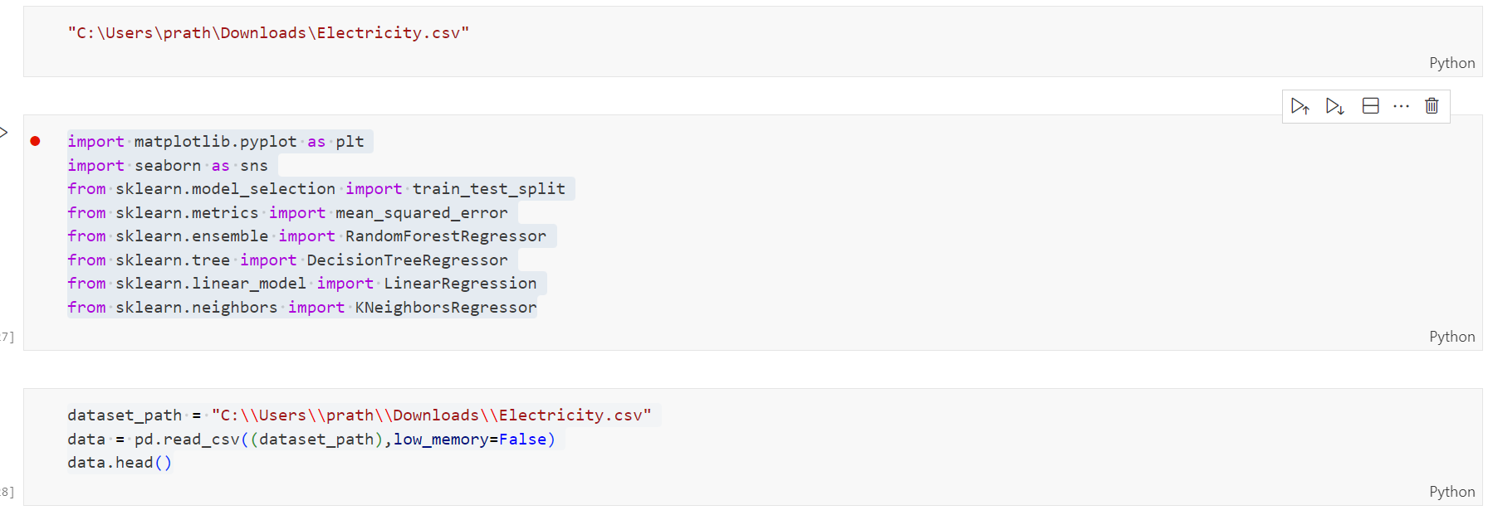

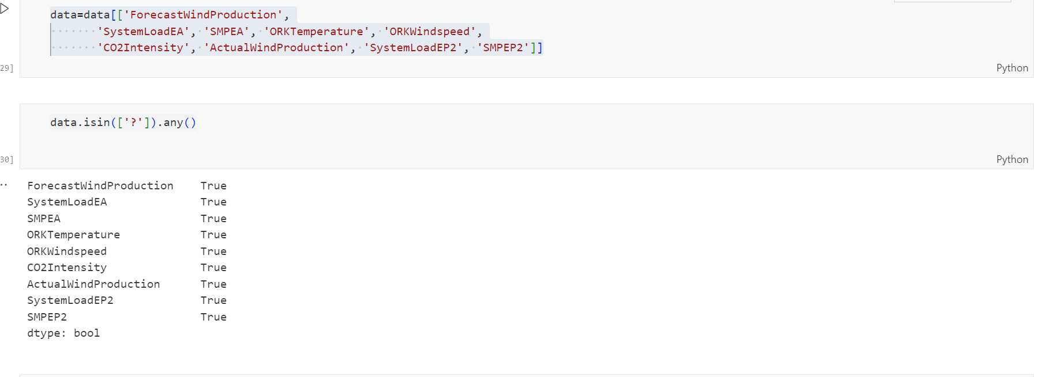

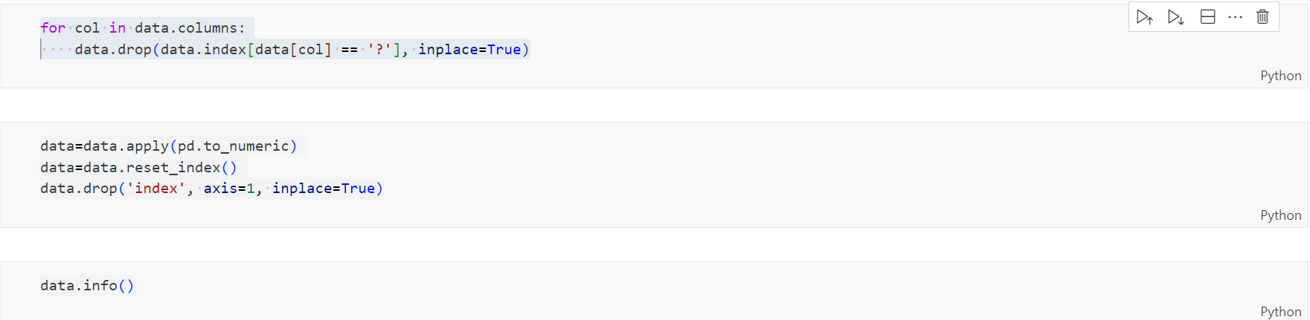

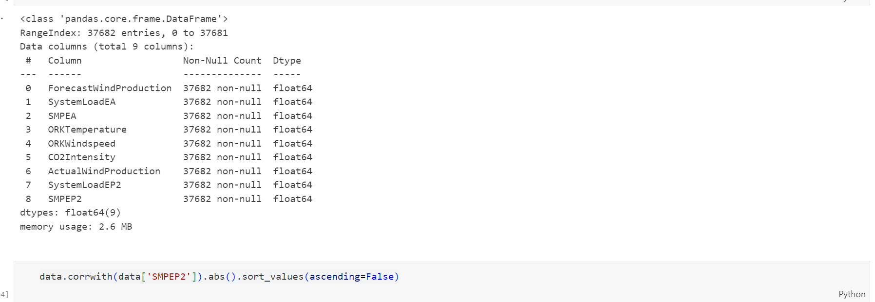

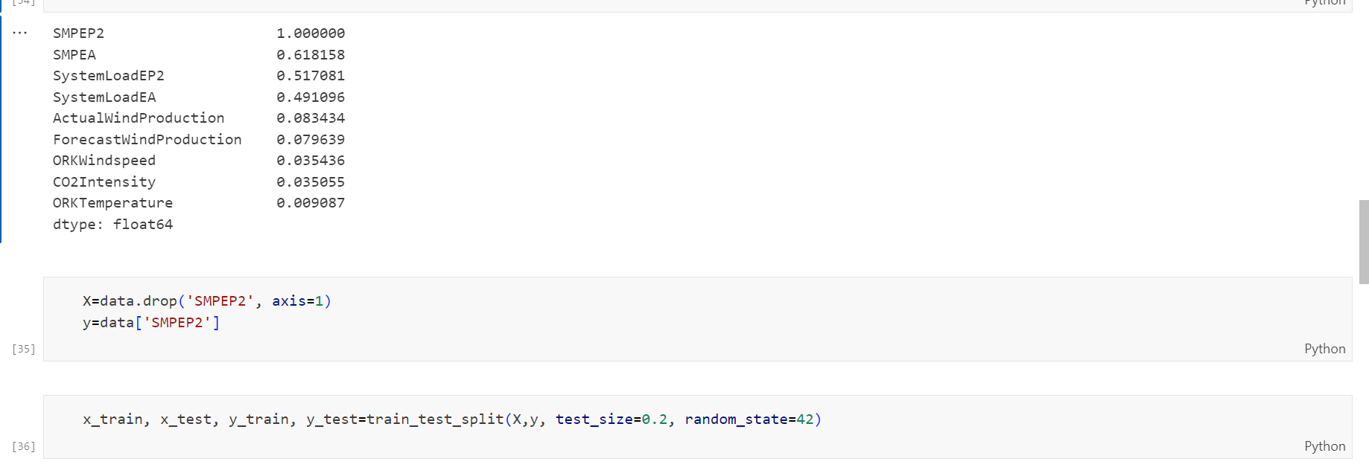

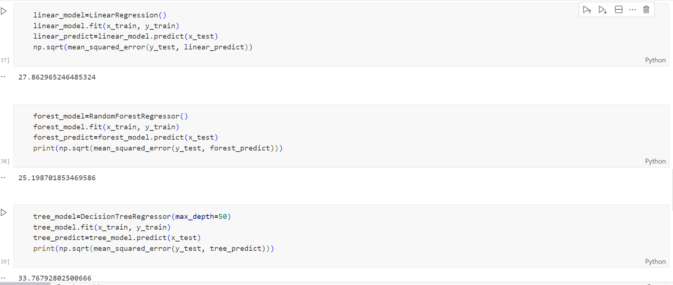

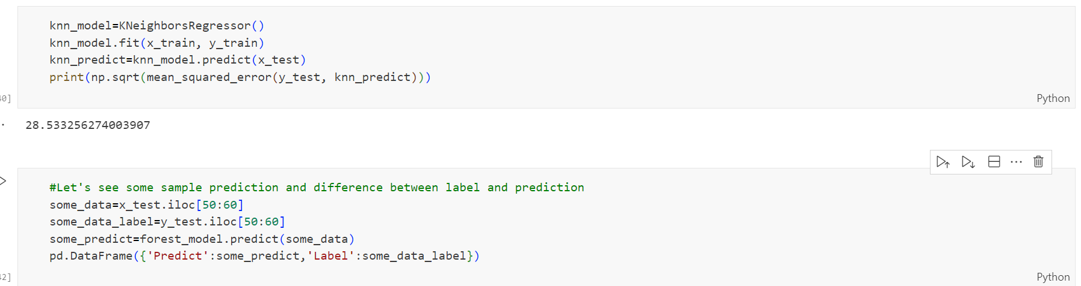

**Thank you**